Statistical Tests raw vectors of model scores
Model A:
- Representing the baseline model, YOLOv5, running against our proposed “Weapon” dataset.
- The evaluation metric Mean Average Precision (mAP) is taken for 10 different runs on the same sequence of test dataset splits as Model B.
- The array of (mAP) values for Model A is:
  - (0.71, 0.74, 0.79, 0.75, 0.76, 0.75, 0.76, 0.72, 0.77, 0.77)
Model B:
- Representing our proposed two-stage model, YOLOv5s & MASK R-CNN-based classifier.
- The evaluation metric Mean Average Precision (mAP) is taken for 10 different runs on the same sequence of test dataset splits as Model A.
- The array of (mAP) values for Model B is:
  - (0.78, 0.81, 0.86, 0.83, 0.84, 0.83, 0.83, 0.79, 0.85, 0.84)

Actual run about screen shot
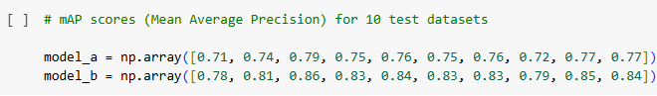
- Two models’ mAP arrayes for ten different datasets
- Output p-value of Shapiro-Wilk test for data normality
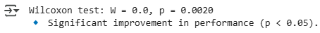
- Output of the chosen “p-value” test (Wilcoxon test)
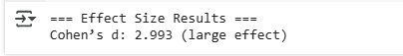
- Output of the chosen “effect size” test (Cohen’s d)
Statistical tests results showing that siginificant improvement was done by using our proposed model

